RENTAL CAR SYSTEM



**CPIT-251 PROJECT**

|  |  |
| --- | --- |
| Name | ID |
| Rayan Essam Taj | **1740377** |
| Faisal Faiz Saharti | **1741977** |
| Abdul-Rahman Hani Al-Johani | **1750624** |

**Project Description**

“Rental Car System” is a project that provides a customer weather it’s an individual person or an organization the ability to search for their preferred vehicle through specifying variety of filters and then acquiring/renting this vehicle for a specific amount of time and a pre-paid price. The system’s simplicity & accuracy is what makes it special, by having advanced filters, the user will be happy because he will be checking the preferred specifications for his ‘dream’ vehicle, and it varies from selecting the preferred branch of the vehicle, color of the vehicle, up to checking if the vehicle has a cruse option or not. The way the system works or the flow of the system is pretty simple & can be very advantageous, the user logs in to the system by using an e-mail and a password that must be created in order for the system to work fully, the next option is making the user checks a variety of basic filters, furthermore there can be some advanced filters that the user can specify in order to achieve complete satisfaction in searching for his ‘dream’ car, after browsing the list of cars that have been filters and shown, the user selects the one that is most suitable for him, the system will check the car availability from the specific branch that has been chosen earlier and the select date as well as the end date in the filtering phase, if its available the system will continue. Then the system will ask for the user to enter payment information in order to pay for the renting procedure, the system will book the car and create a reservation for the user, and show the reservation details for the user (reservation vehicle, pick-up location, drop-off location). The system also provides the history of all reservations for the user if the user wants to check the reservations that he has made throughout his life in the system to check the details of said reservation and checking if the reservation is still valid or not, providing a complete experience profile for the user.

**Feasibility Study**

|  |  |  |  |
| --- | --- | --- | --- |
| **Serial No.** | **Feasibility Concern** | **Status** | **Reasons** |
| 1 | **Economical** | Satisfied | Our System will not cost a lot of money.  The only thing that the system will need is a database in order to keep everything synchronized through all the branches. |
| 2 | **Technical** | Satisfied | We are going to need to draw the customers in order to tell them why they should use this website, because it is simple, easy to learn and use for all types of users as it caters to universal usability. |
| 3 | **Organizational** | Satisfied | it will be very convenient for the customer to find what he wants so easily and quickly. They will be only a few checks away from renting the car that they need. |
| 4 | **Schedule** | Satisfied | The system will not need that much of a time or won’t take up that much of a schedule in setting up the system, the schedule will consist of interviewing users to see which filters they usually search for, and then construct a database through it in order to launch the system. |

**GANT CHART FOR THE SYSTEM**

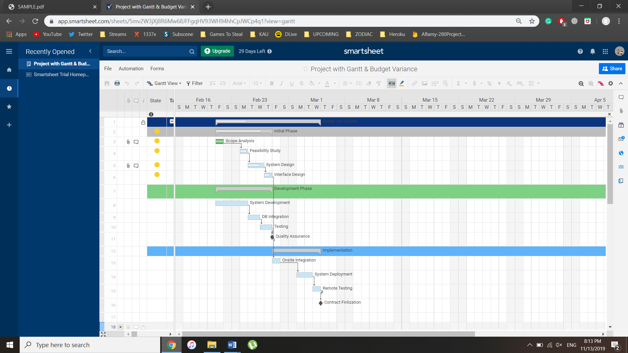

**Functional Requirements Specification** :

**1)**

**[MANAGE MOVIE]**

**Description:**

In this function, the Admin of the System can Manage the movies in the System (Adding a new movie, Specifying the Date, Delete a Movie from the System, Update Movies’ Information).

**Priority:**

This is a very crucial function, because movies need to be added for the system to be working.

**Requirements:**

* REQ-1: The Admin needs to complete the function [LOGIN].
* REQ-2: Database to store Movie’s Information (Movie Title, Movie Date, Price…etc).
* REQ-3: An Interface with fields to be filled in by the Admin, with a Calendar Field to check any confliction.
* REQ-4: Admin Account Verification/Password Entry.

**2)**

**[GET TICKET]**

**Description:**

In this function, a Ticket ID is generated and is confirmed & sent to the user to be able to get Access to the Movie Hall.

**Priority:**

This is a Very High Priority, because this is the main goal of the System which is to Acquire the

Tickets.

**Requirements:**

* REQ-1: the other Function [PAY] needs to be completed, because a User receives his ticket only
* after he/she has paid.
* REQ-2: Account/Credit Card Verification.
* REQ-3: Database to add the user to the list of bookings.

**3)**

**[BROWSE LIST OF BOOKINGS]**

**Description:**

In this function, the Admin of the System checks the Database to browse the List of registered users and their movie bookings if any problem occurs & Cancel a Reservation for a user if requested.

**Priority:**

This has high Importance, because if a problem occurs, the Admin can enter the System and check the seat’s holder for that specific movie.

**Requirements:**

* REQ-1: The Admin needs to complete the Function [LOGIN].
* REQ-2: Interface with fields to Search for Movie Title & Date, or a Specific User.
* REQ-3: Database to Retrieve the List of Bookings.

**Function Modeling**

**Use Case Diagram**

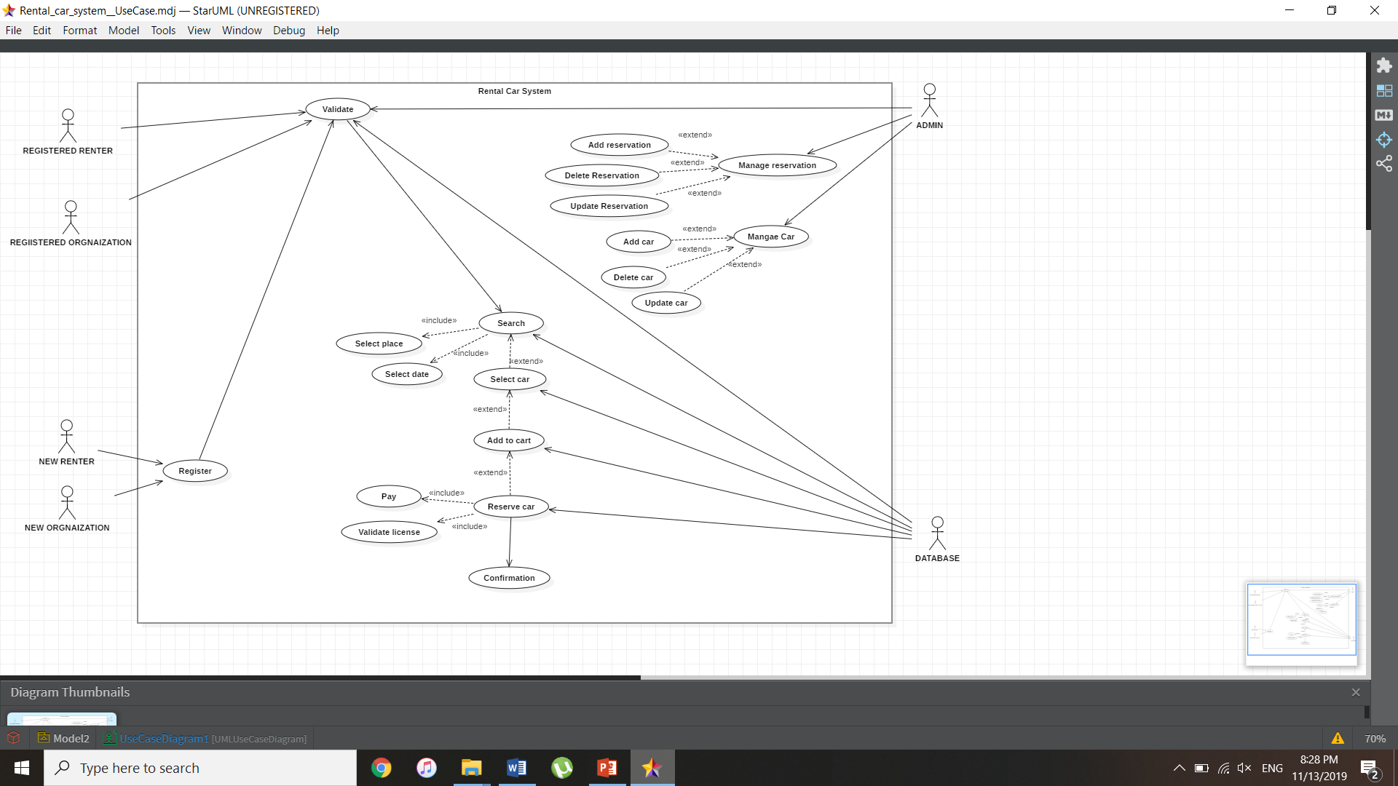

**Class Diagram :**

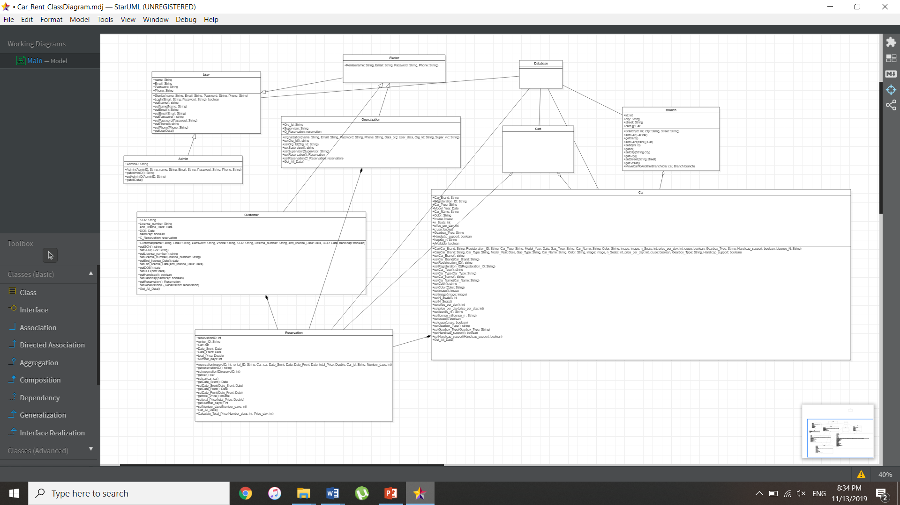

**Sequence Diagram :**